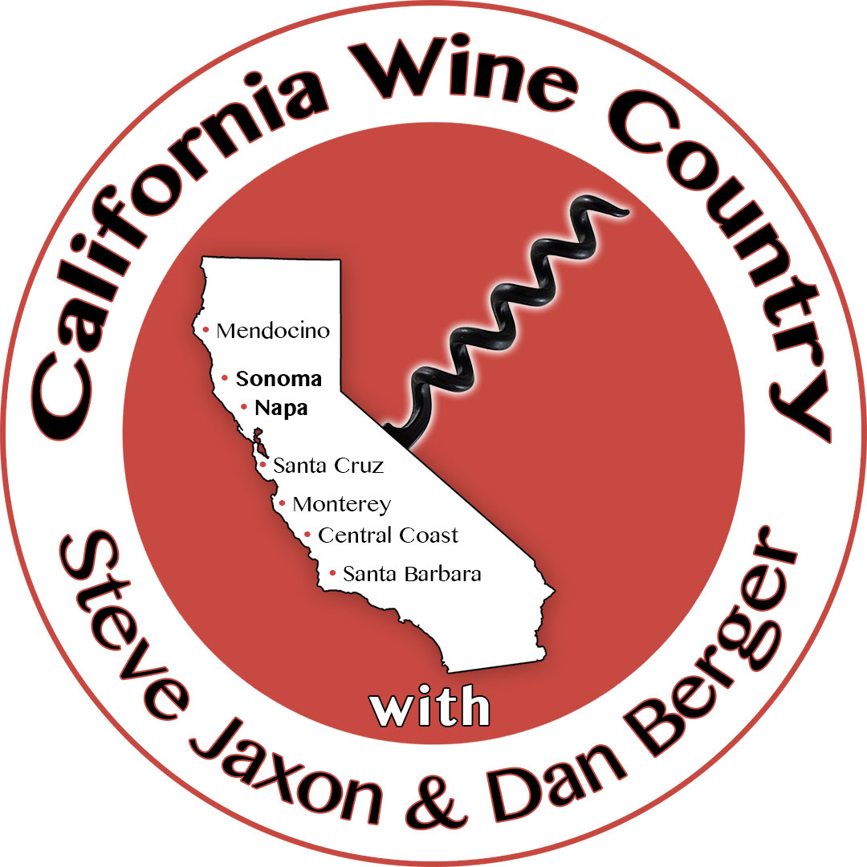

LISTEN ON THE RADIO
Live on KSRO 1350 AM & 103.5 FM, Wednesdays from 5-6 pm.

SUBSCRIBE TO THE PODCAST
Find California Wine Country on iTunes, Android, Stitcher,
etc. and at
www.calwinecountry.com

